OFFICE OF RECIPIENT RIGHTS
SITE VISIT MONITORING FORM (CMH SITE VISITS)

SERVICE SITE: PROVIDER:
DATE OF VISIT: ASSESSOR:
TYPE: Group Home: □MI □ DD _____ Number of Residents │ Day Program: □ MI □ DD │ Workshop: □ MI □ DD │□ACT Program │ □ Outpatient │ □ Clubhouse/Drop-in Center │ □ Other:

YES | NO | STANDARD | COMMENTS | GUIDELINES
 |  | Were rights books provided to consumers and readily available for review? |  | Rights book should be available to consumers; not stored in the office or other location that is not acceptable  Rights Book should be the latest version (see below)
 |  | Did the rights books provide the correct information for contacting the appropriate Rights Office? | List the CMHs and name(s) of Rights Staff observed on the books. | Consumers must be able to identify who their Rights Office is. If the home has consumers from more than one CMH each should have the appropriate information.
 |  | Are posters providing contact information for the Rights Office conspicuously posted and visible to consumers and staff? (not applicable to SIP sites) |  | Poster identifying the appropriate Rights Office must be posted in conspicuous areas.
 |  | Did the posters provide the correct information for contacting the appropriate Rights Office? | List the CMHs and name(s) of Rights Staff observed on the posters. | Same as above
 |  | The most current version of the Abuse and Neglect Reporting Posters are posted where staff can see them. |  | The poster should be orange and white dated 4/2018 see below
 |  | Were complaint forms readily available? |  | Complaint forms must be available in common areas; consumers should not have to ask staff for complaint forms.
 |  | Were recipients aware of how to file a complaint? |  | Reviewer should ask at least 2 consumers
 |  | Were staff aware of how to file a complaint? |  | Reviewer should ask at least 2 staff
 |  | Were copies of Chapter 7 and 7A available? |  | Printed copies of Chapters 7 and 7A of the Mental Health Code should be available in a common area.
 |  | Were any exclusions to items able to be brought into the site (contraband) posted and visible to consumers and visitors?
 |  | Were records and other confidential information secured and not open for public inspection?
 |  | Were any health or safety concerns identified during the visit?
 |  | Were appropriate accommodations made for persons with physical disabilities?
 |  | Documentation that staff received RR training within 30 days of hire was reviewed? |  | The reviewer no longer has to check for this; CMH will be asked, at time of assessment, to provide this information
Observations:

Deficiencies Notes and Required Action:

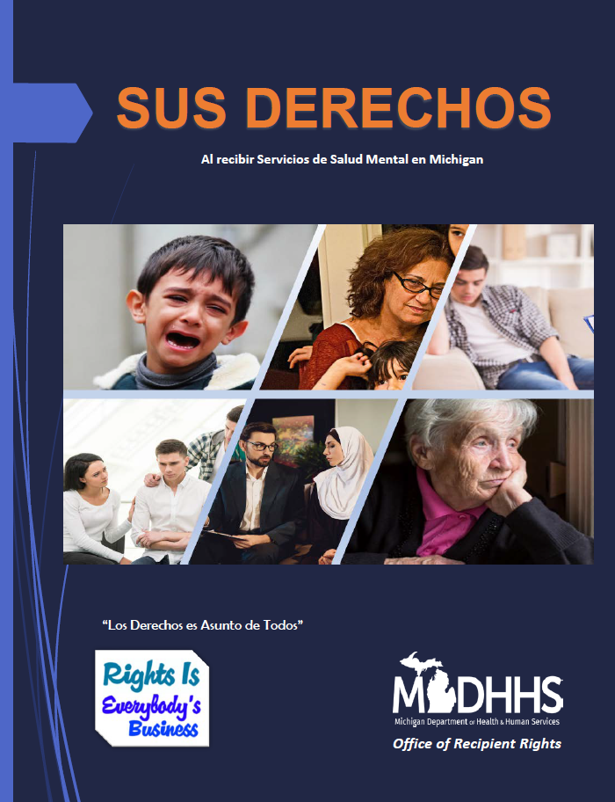
No Publication Date Publication Date 6/2019
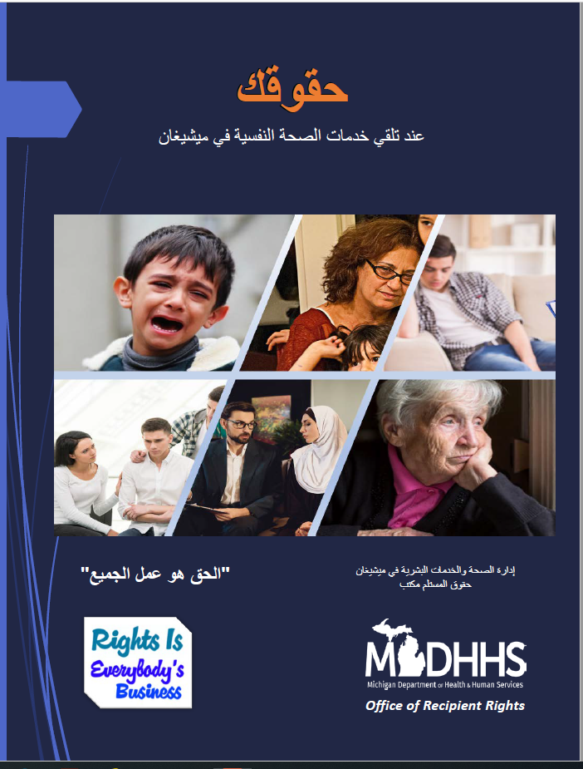

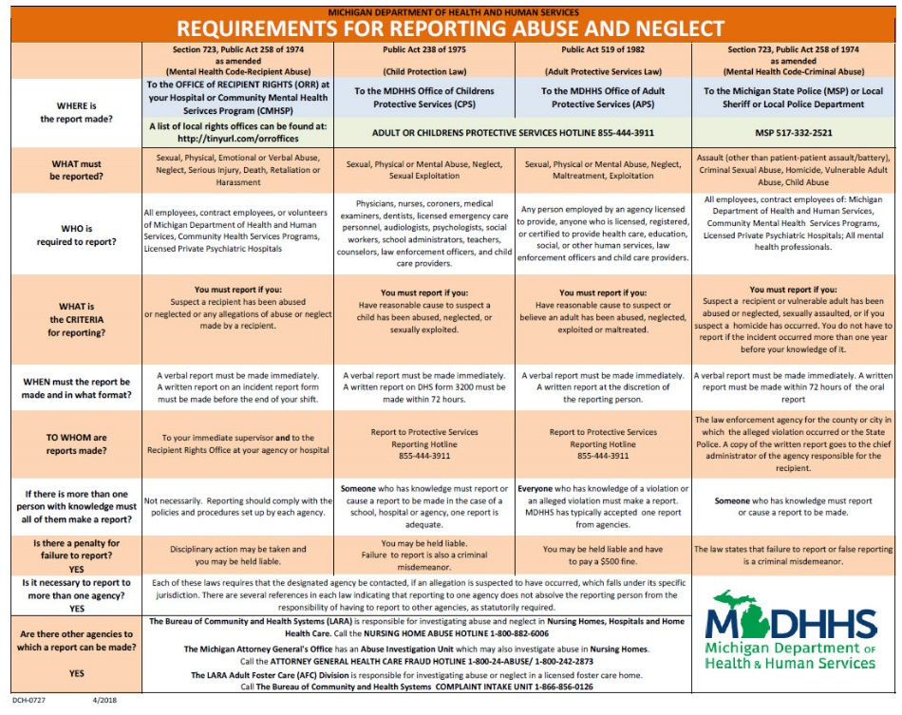
Publication Date 6/2019 Publication Date 4/2018

