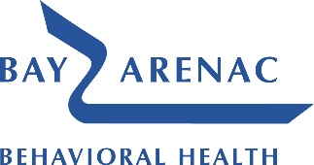
Customer Service 909 Washington Avenue, Suite 3, Bay City, MI 48708
Phone: (989) 497-1302 or toll free (888) 482-8269 Fax: (989) 895-2715

Grievance Submission Form
A Grievance is a consumer’s expression of dissatisfaction about service issues, other than an adverse action, which does not involve a recipient rights complaint. Possible subjects for grievances include, but are not limited to, quality of care or services provided, interpersonal relationships with service providers or facility issues. Grievances may be filed at any time by a consumer, consumer’s guardian, or a parent of a minor child or a consumer’s legal representative.
Name: |  | Submission Date:
Mailing Address: |  | Contact Phone Number:
Consumer Name: (if different) |  | Consumer Date of Birth:
Consumer Mailing Address: |  | Consumer Phone Number:
- Reason for Grievance: (additional space on back, if needed)
- What would you like to see happen to address your grievance?
Consumer or Legal  Guardian Signature: |  | Date:
Once this form is received, you will be sent an acknowledgement letter. All grievances will be resolved within 90 calendar days if you have Medicaid / Healthy Michigan Plan or 60 calendar days if you do not. This form can be dropped off, mailed in, or faxed to Bay Arenac Behavioral Health Customer Service. Assistance is available by contacting Customer Service at (989) 497-1302 or toll free (888) 482-8269.

- Reason for Grievance (Continued):
- What would you like to see happen? (Continued):

Internal use only:
Date received: ___________________________ Received by:____________________________

